Prediction of Hospital Admission Using Machine Learning

In this paper author is using various machine learning algorithm to predict patient admission at ED (emergency department) and then evaluating performance between all those algorithms and in propose paper author has used Random Forest, Naïve Bayes and SVM and among all algorithms SVM is giving better performance and we have extended paper with deep learning algorithms such as LSTM and CNN and among all algorithms CNN (Convolution Neural Networks) is giving best prediction result.

At present hospital will use ED admission only for accident and emergency patient and the patients which require urgent admission has to wait to complete all admission procedure to get admission bed and treatment and this delay will cause major harm to patient health and if hospital peoples take all patients and ED then it will be over crowded. To overcome from this problem author is employing various machine learning algorithms which will be trained with patient past history data such as Heart Rate, Age, Gender, BP and diabetes. This trained model can be input with new patient test samples and then this machine learning trained model will predict whether patient required admission or not. Based on machine learning prediction hospital peoples can manage ED admission efficiently.

To implement this project we have used TRIAGE ED admission dataset and below screen showing some details from the dataset.

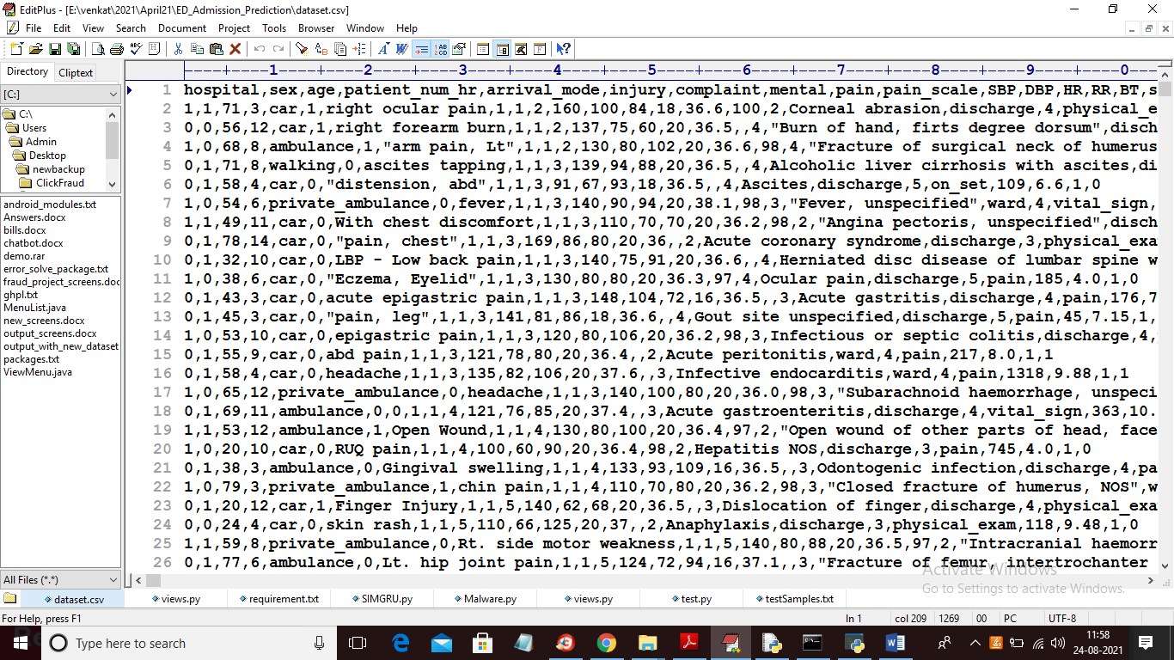

In above dataset first row contains dataset column names and remaining rows contains dataset values and this dataset contains, sex, age HR, BP, diabetes and many more patient condition samples and machine learning algorithms will be trained with above dataset. In dataset in last column we have class label as 0 or 1 where 1 means that patient record required ADMISSION and 0 means that patient record NOT REQUIRED ADMISSION. In below screen of dataset you can see admission column class label

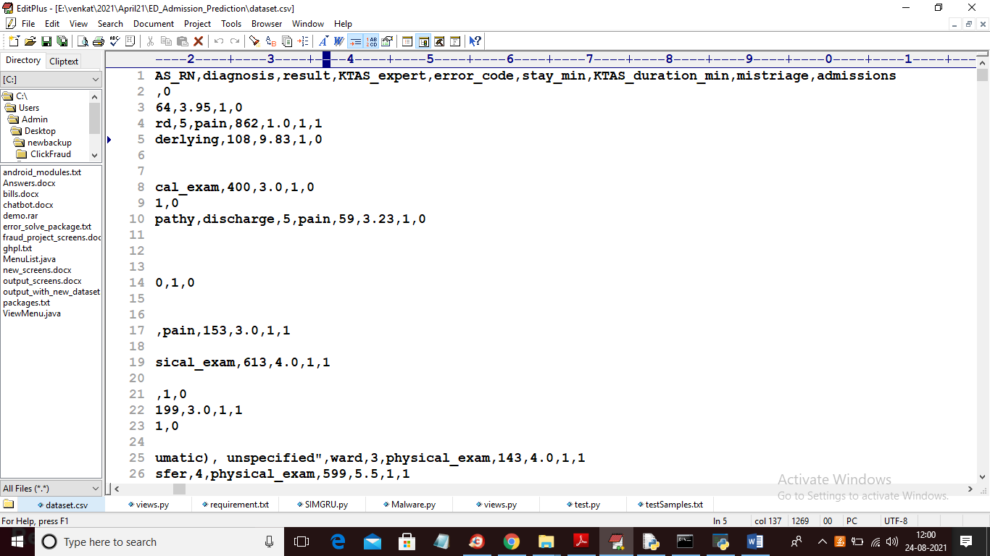

In above dataset screen in last column you can see we have class label as 0 or 1.

To implement this project we have designed following modules

1. Upload ED Admission Dataset: using this module we will upload ED admission dataset and then calculate number of patients which require admission and NO admission.
2. Preprocess Dataset: using this module we will read dataset values and then replace missing values with 0 and then split dataset into train and test part. Train data will be used to train ML algorithms and test data will be used for prediction and then calculate prediction accuracy, precision, recall and FSCORE
3. Run SVM Algorithm: using this module we will train SVM algorithm with above dataset and then calculate accuracy
4. Run Random Forest Algorithm: using this module we will train Random Forest algorithm with above dataset and then calculate accuracy
5. Run Naïve Bayes Algorithm: using this module we will train Naïve Bayes algorithm with above dataset and then calculate accuracy
6. Run Logistic Regression Algorithm: using this module we will train Logistic Regression algorithm with above dataset and then calculate accuracy
7. Run MLP Algorithm: using this module we will train Multilayer Perceptron algorithm with above dataset and then calculate accuracy
8. Run CNN Algorithm: using this module we will train CNN algorithm with above dataset and then calculate accuracy
9. Run LSTM Algorithm: using this module we will train LSTM algorithm with above dataset and then calculate accuracy
10. All Algorithms Performance Graph: using this module we will plot comparison graph between all algorithms
11. Predict Admission from Test Data: using this module we will upload new test data samples and then ML algorithms will predict whether that test samples patient require admission or NOT.

Below are the test samples used for admission prediction.

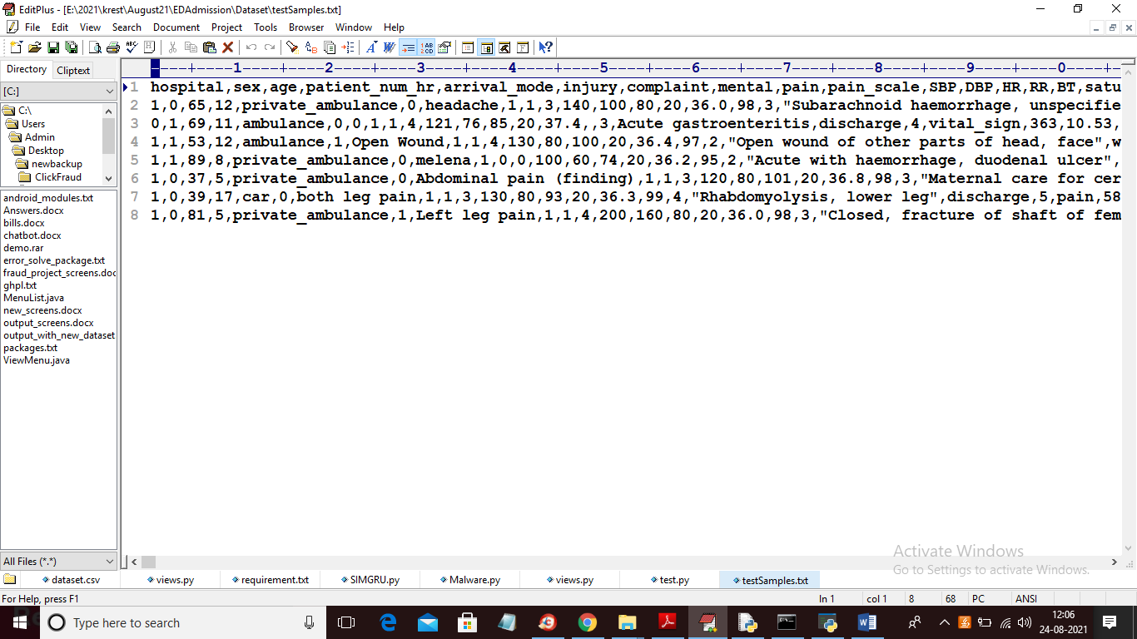

Above are the test samples and in above test samples we don’t have admission column and this admission values will be predicted by ML algorithm by evaluating above test samples. In below screen you can see test samples don’t have admission column

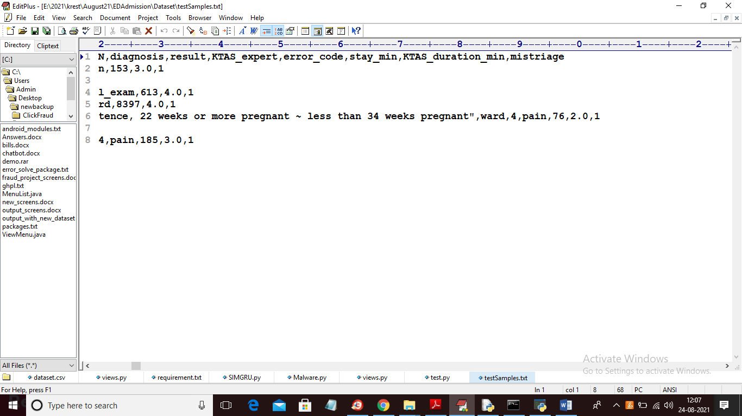

In above screen in test samples we don’t have admission last column and this values will be predicted by ML algorithms.

SCREEN SHOTS

To run project double click on ‘run.bat’ file to get below screen

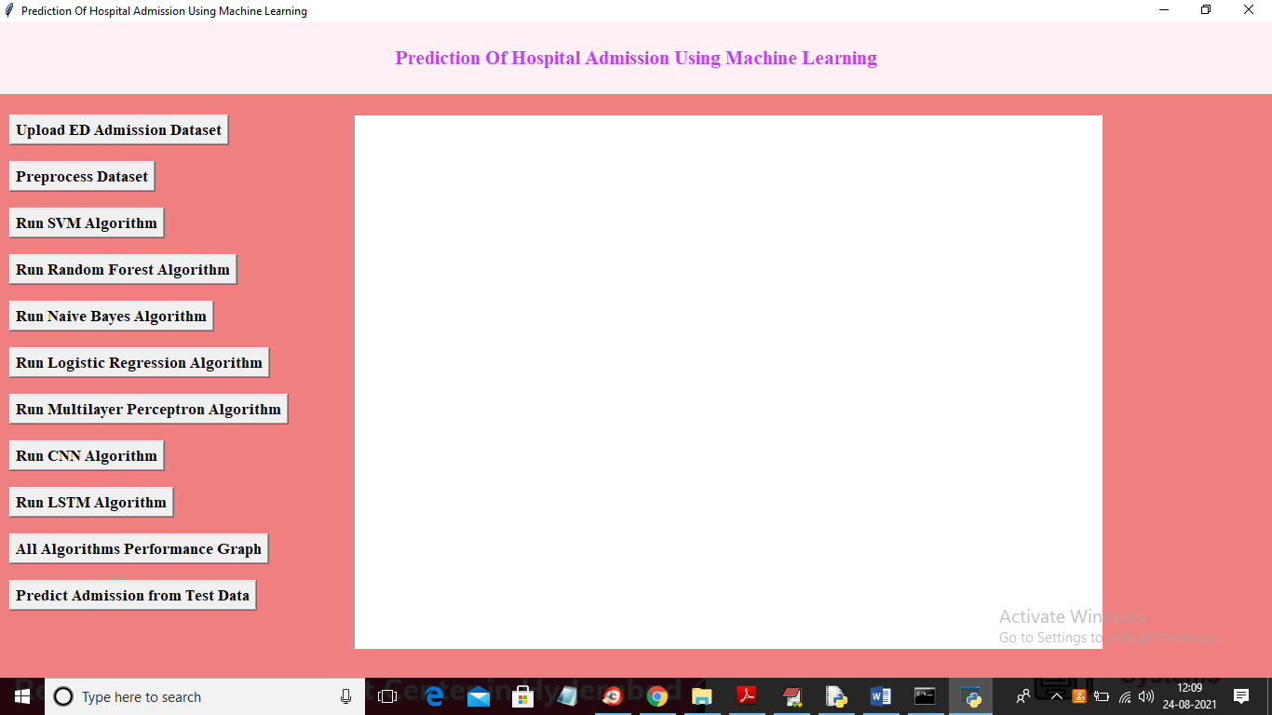

In above screen click on ‘Upload ED Admission Dataset’ button to upload dataset and to get below screen

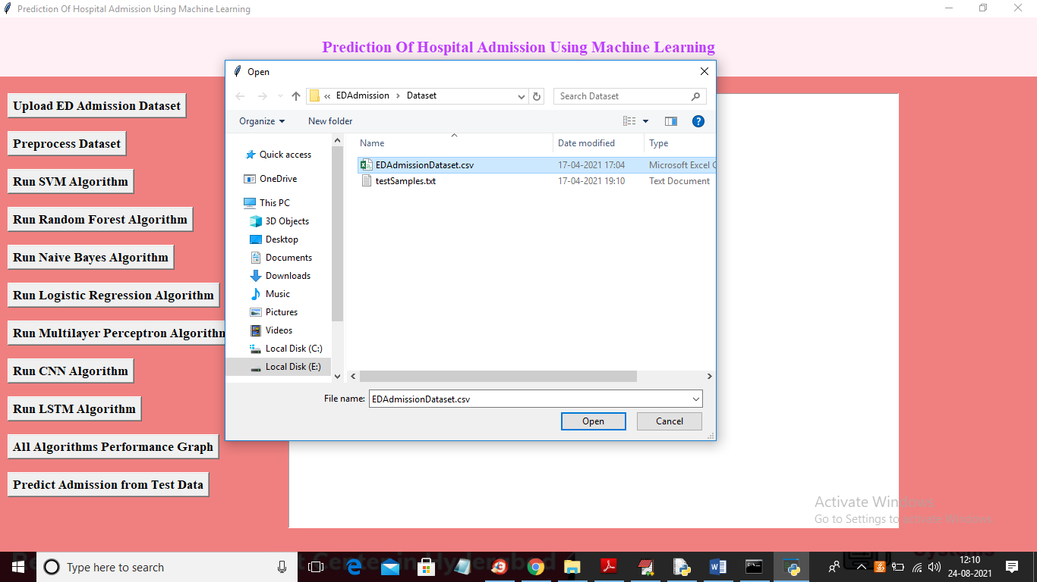

In above screen selecting and uploading ‘EDAdmissionDataset.csv’ file and then click on ‘Open’ button to load dataset and to get below screen

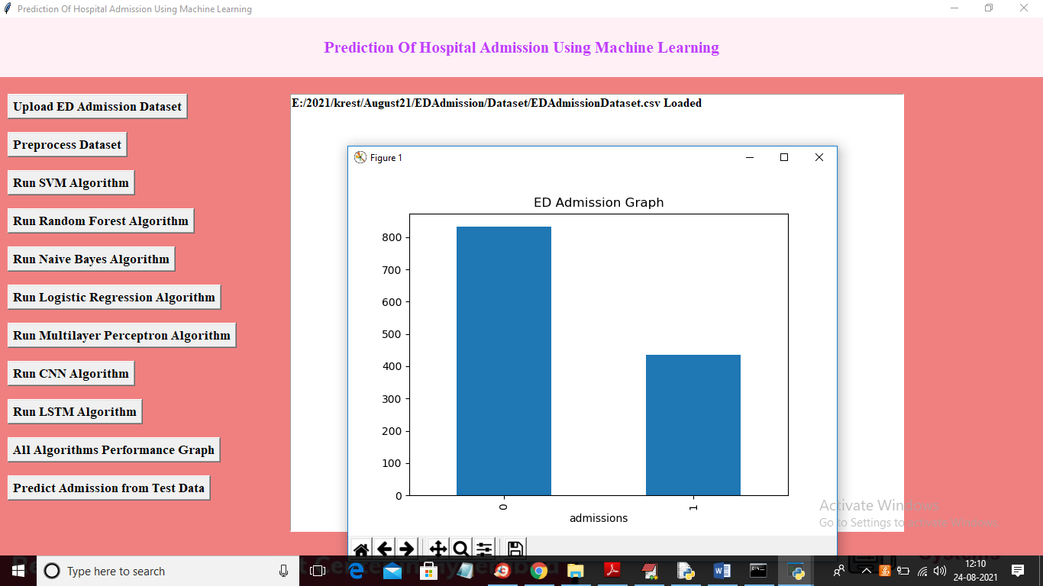

In above screen dataset loaded and from dataset we find out total number of patients require admission or not and then we plot in graph. In above graph x-axis contains values 0 (no admission) and 1 means (admission required) and y-axis represents counts of those patients. Now close above graph and then click on ‘Preprocess Dataset’ button to read dataset and then clean and then split dataset into train and test part

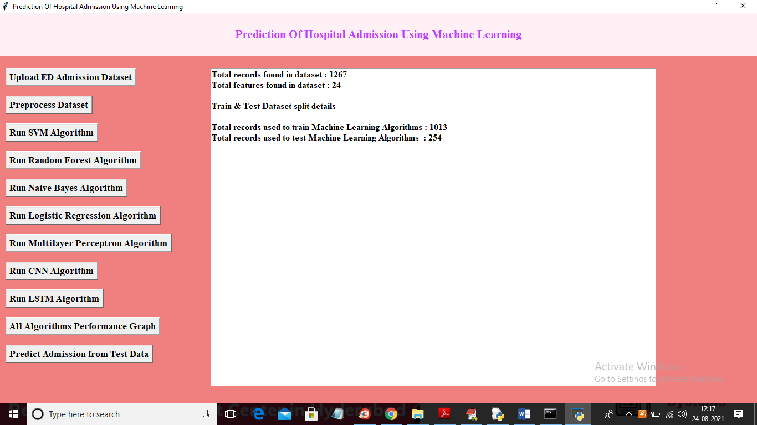

In above screen we can see dataset contains 1267 records and each record contains 24 columns/features and then split dataset into train and test where application using 1013 records for training and 254 for testing. Now dataset is ready and now click on ‘Run SVM Algorithm’ button to train SVM with above dataset

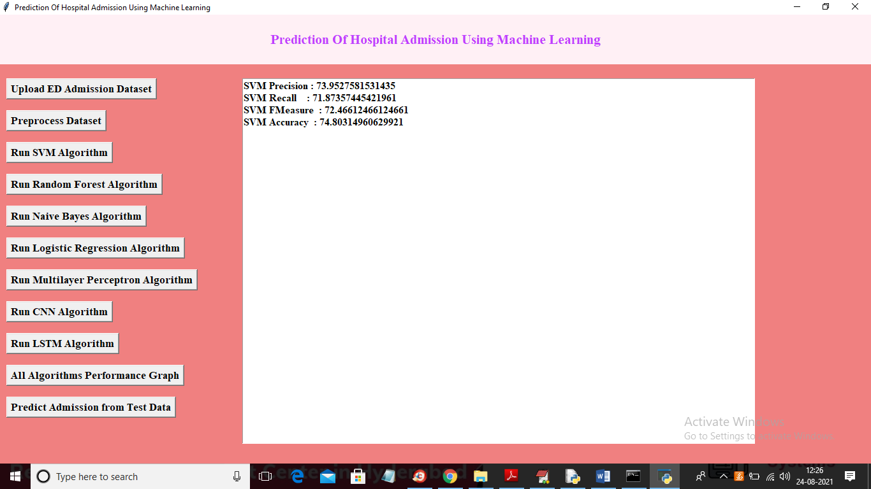

In above screen SVM is trained and we got its accuracy and other metrics and now click on ‘Run Random Forest Algorithm’ button to train Random Forest and to get below output

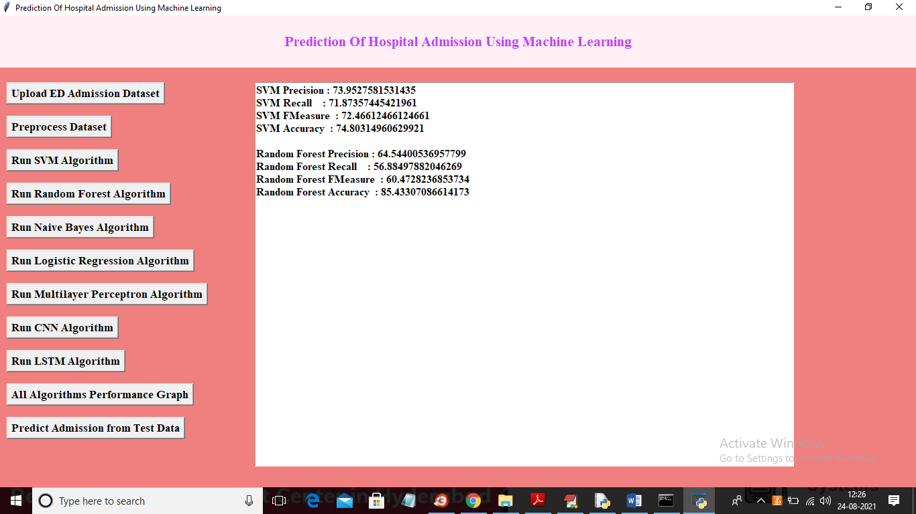

In above screen we got Random Forest output and now click on ‘Run Naïve Bayes Algorithm’ to get below output

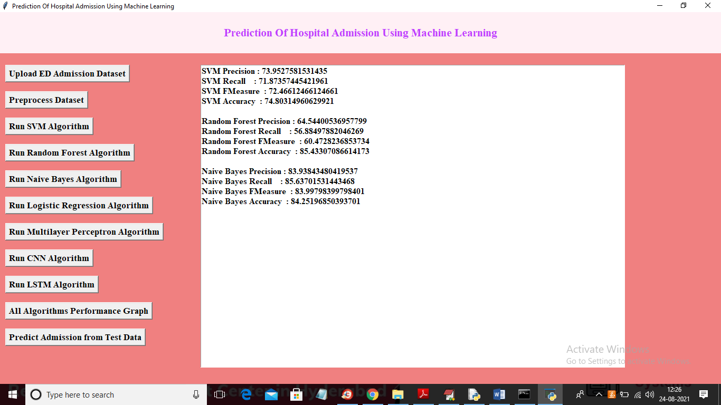

In above screen we got Naïve Bayes output and now click on ‘Run Logistic Regression Algorithm’ button to get its output

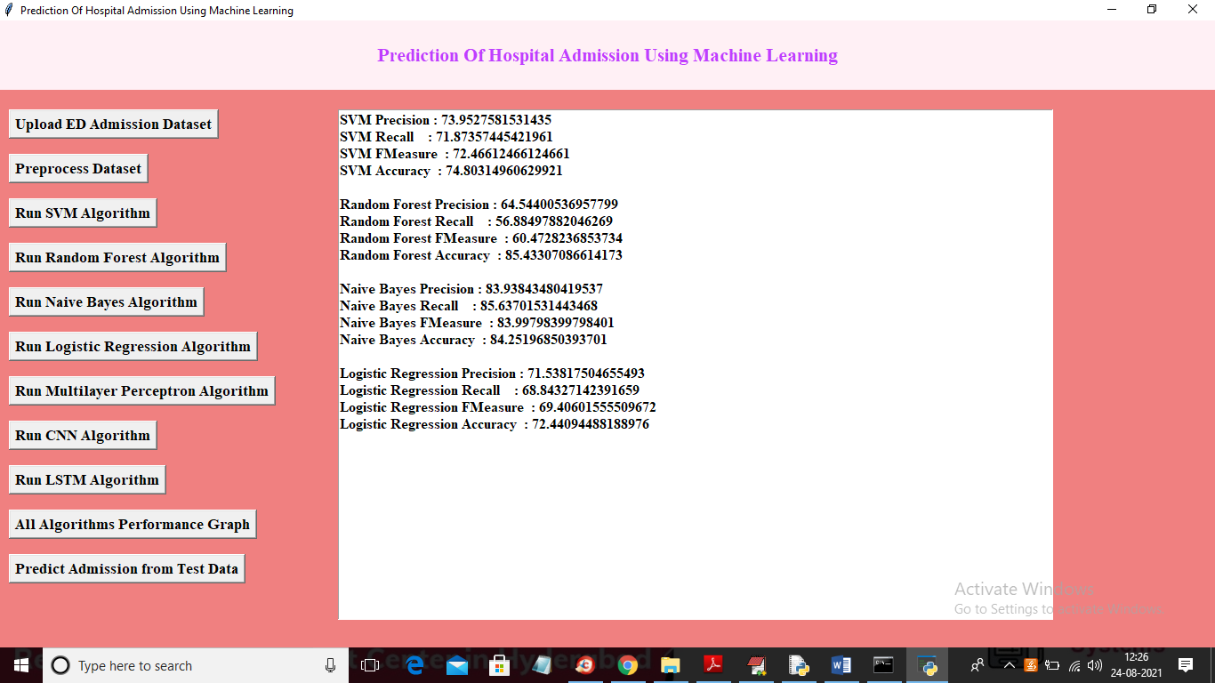

In above screen we got Logistic Regression output and now click on ‘Run Multilayer Perceptron Algorithm’ button to get its output

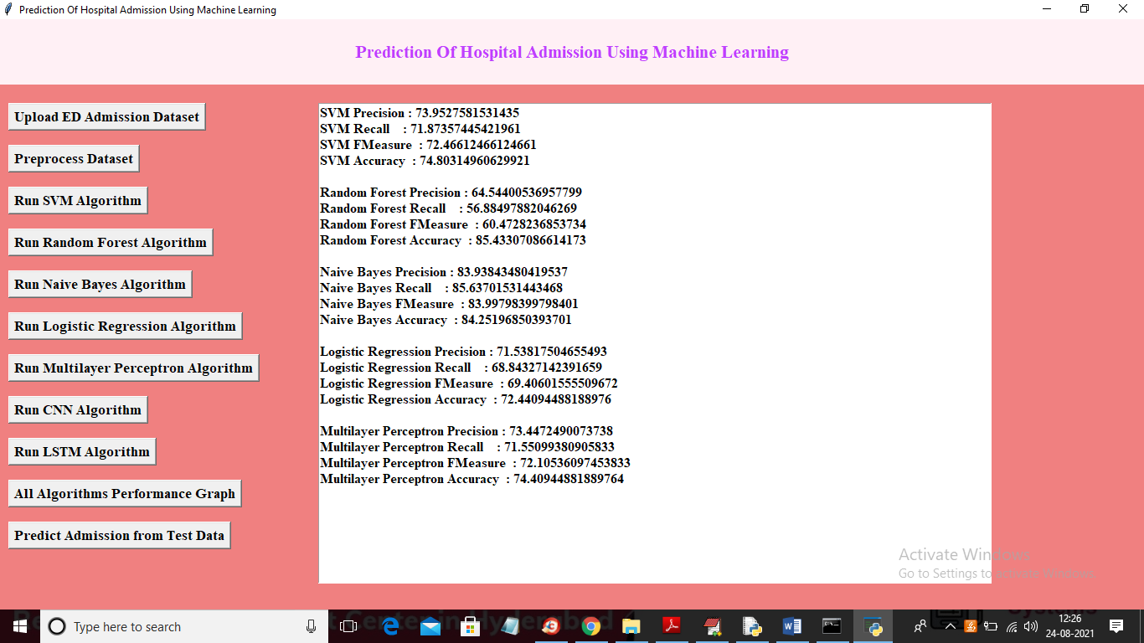

In above screen we got Multilayer Perceptron output and now click on ‘Run CNN Algorithm’ button to train CNN with above dataset and to get below output

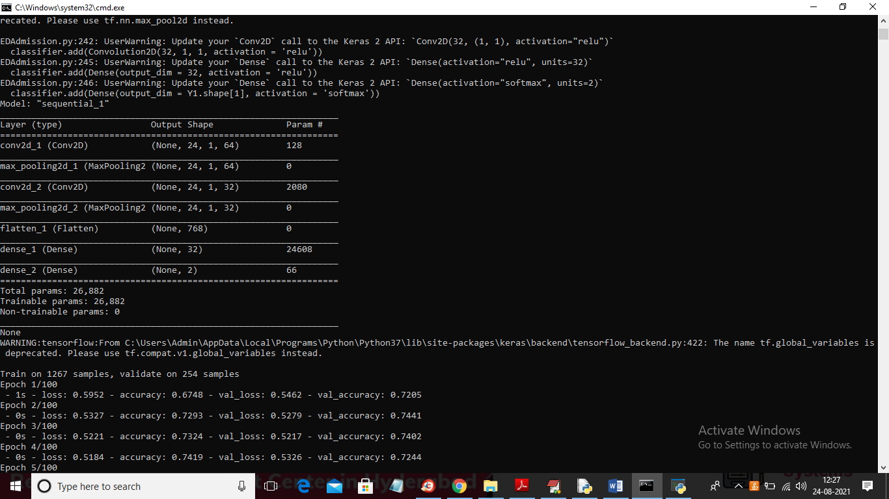

In above screen we can see Convolution2D algorithms start training dataset and after training will get below output

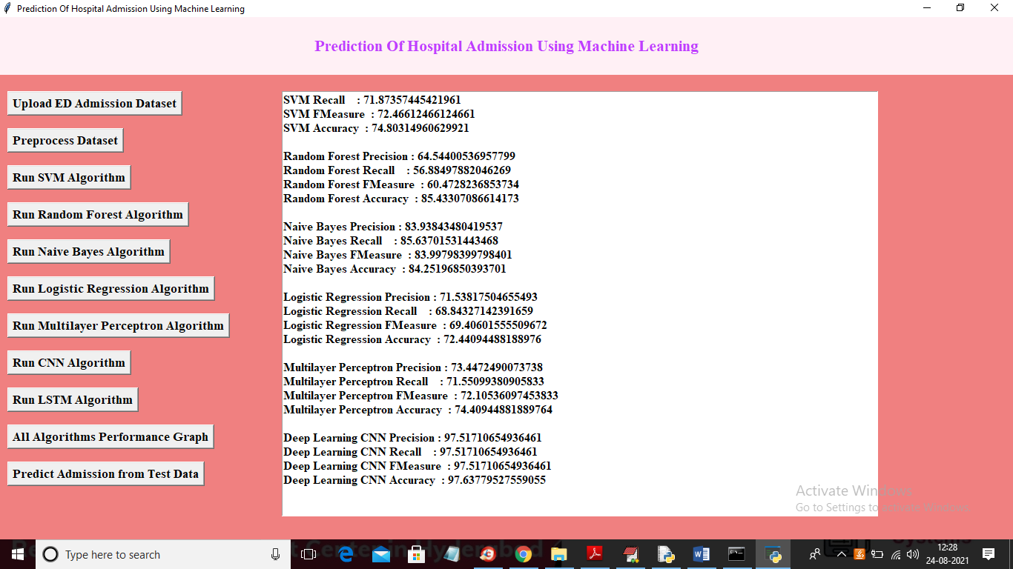

In above screen with CNN we got 97% accuracy which is higher than other algorithms and now click on ‘Run LSTM Algorithm’ button to train LSTM and to get below output

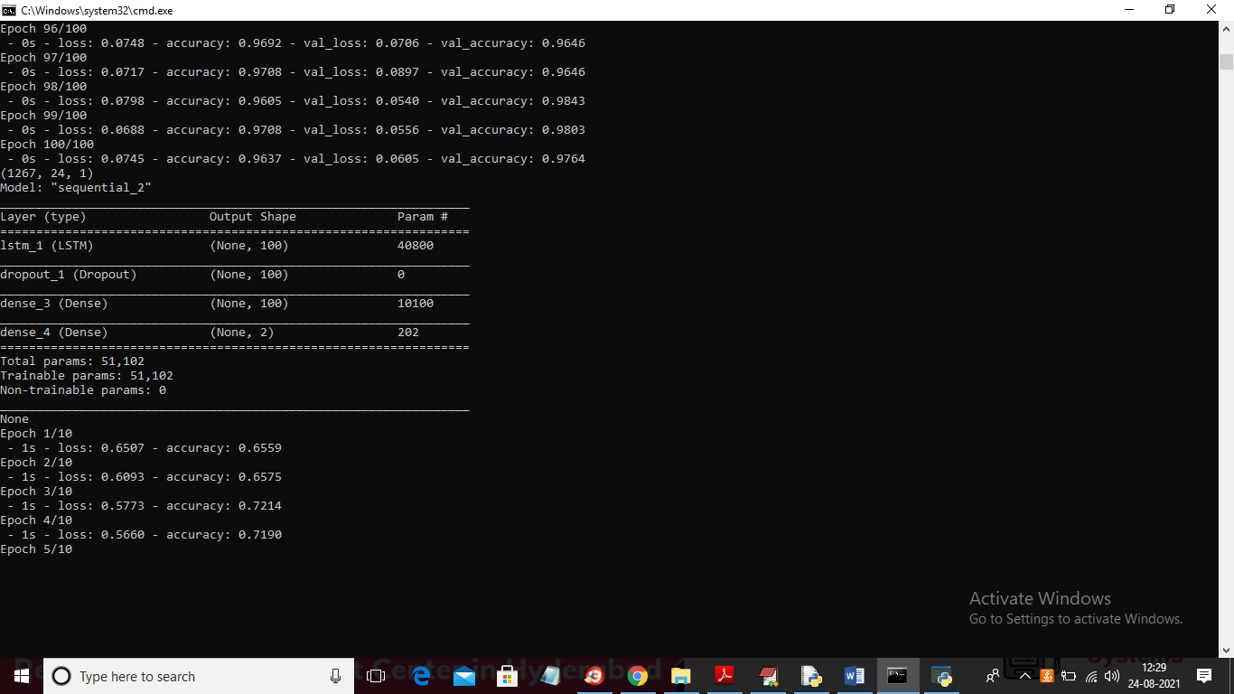

In above screen we can see LSTM start training dataset and after training dataset will get below output

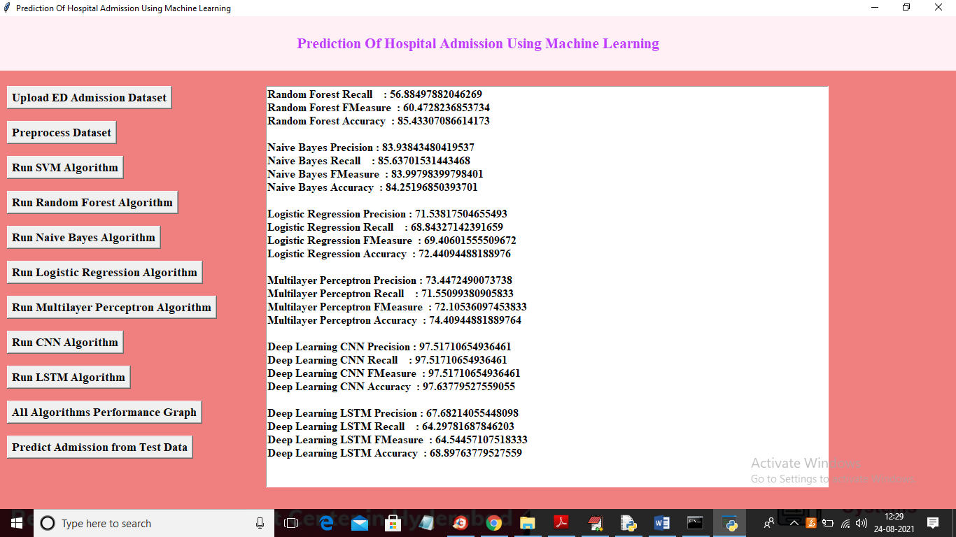

In above screen we got LSTM output and now click on ‘All Algorithms Performance Graph’ button to get below graph

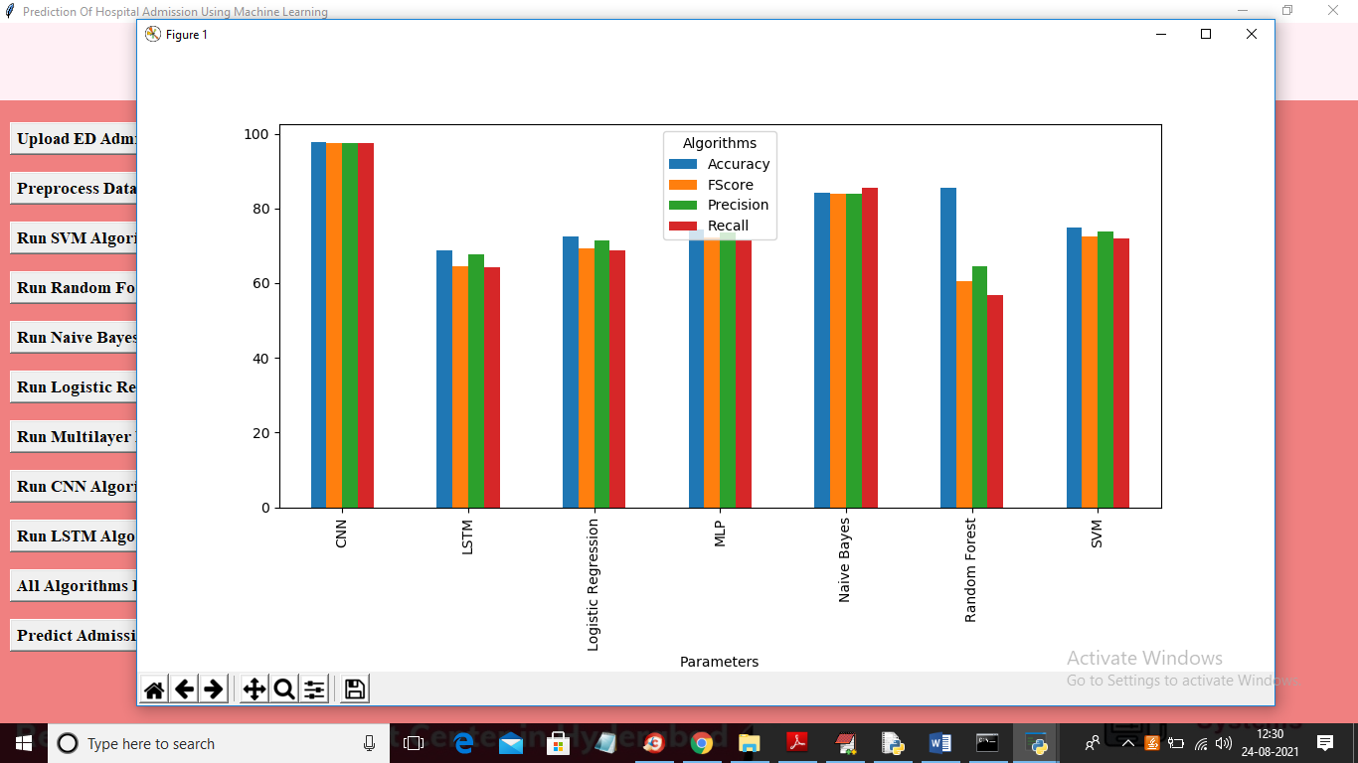

In above graph x-axis represents algorithm names with each metric bar in different colours (precision, recall, FSCORE and accuracy) and y-axis represents values. In above graph we can see compare to all algorithms CNN is giving better prediction accuracy. Now click on ‘Predict Admission from Test Data’ button to upload test samples and to get prediction result

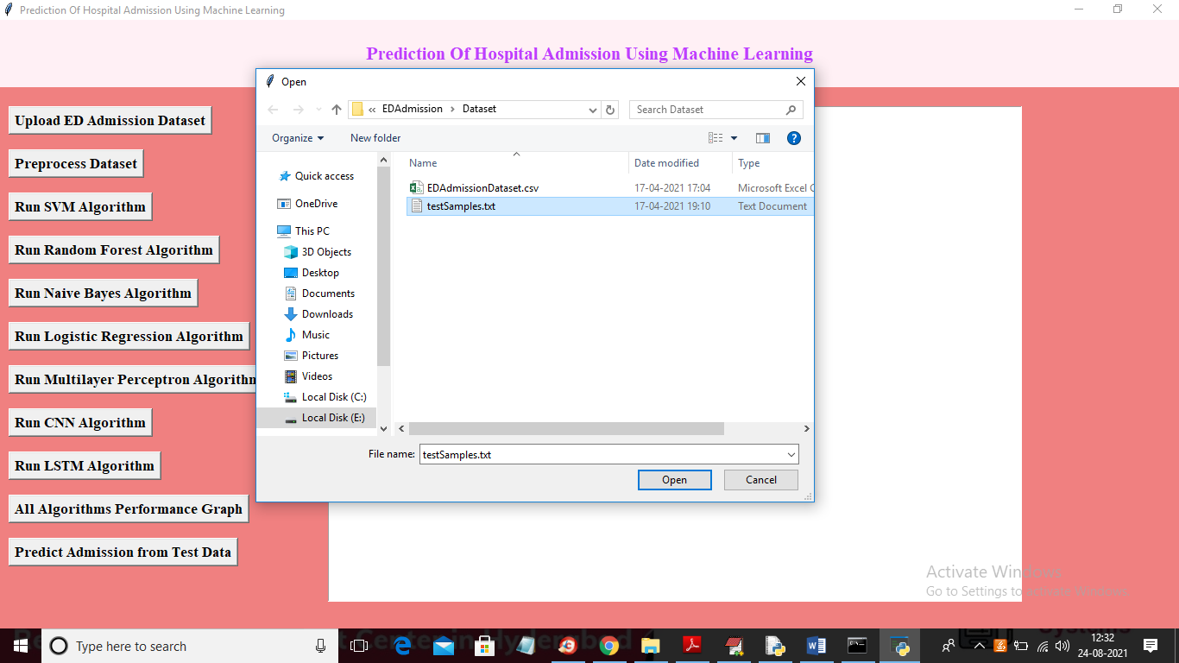

In above screen selecting and uploading ‘testSamples.txt’ file and then click on ‘Open’ button to get below prediction result

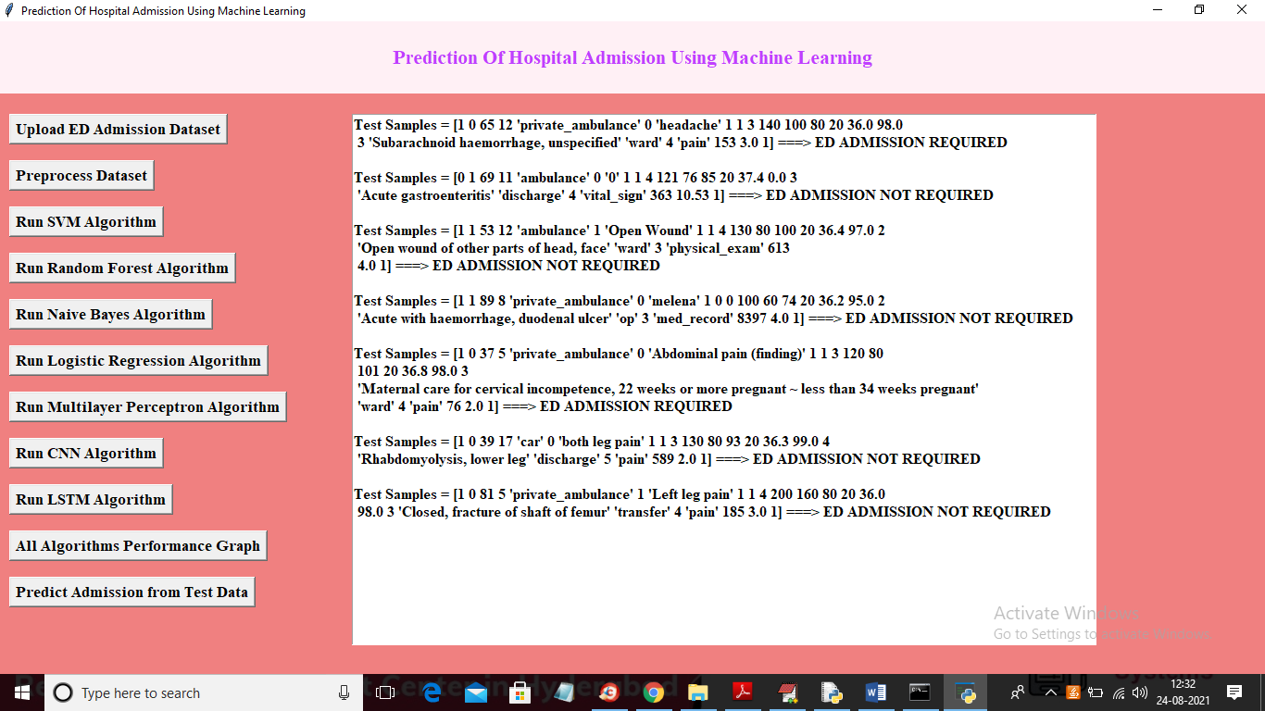

In above screen inside square brackets we can see patient test samples and after arrow symbol we can see prediction result for that test samples as ‘ED ADMISSION REQUIRED’ or ‘ED ADMISSION NOT REQUIRED’